

**Assignment-Python**

Course Instructor: **Muhammad Ataur Rahman**

Senior Lecturer,

Department of Business Administration

**Summer-2023**

Course Code: MIS-403

Course Title: Object Oriented Programming

**Submitted by**

Name:Rizwan Hassan

ID: 2019-2-10-148

|  |
| --- |
| 1. Syntax, Input, Print |

a=input('NAME:')

b=input('AGE:')

print('Your Name is ' ,a,' and age is ',b)

|  |
| --- |
|  |

|  |
| --- |
| 2. Variables (numbers, strings) |

n=1

t='Ahsan'

q=2

r='Rizwan'

print(n,t,'\n',q,r)

|  |
| --- |
|  |

|  |
| --- |
| 3. Integers and Decimal Numbers |

a=input('NAME:')

b=int(input('AGE:'))

c=float(input('CGPA:'))

print('Your Name is ' ,a,',your age is ',b,'and your CGPA is',c)

|  |
| --- |
|  |

|  |
| --- |
| 4. Math operators (+, -, *, **, /, //, %) |

a=14

b=10

p=a+b

m=a-b

g=a*b

po=b**2

d=a/b

c=a//4

r=a%b

print('p=',p,'m=',m,'g=',g,'po=',po,'d=',d,'c=',c,'r=',r)

**output-**

|  |
| --- |
|  |

|  |
| --- |
| 5. Math functions (round, avg, sqrt, floor, ceil) |

import math

a=float(14.68)

b=float(10.56)

r=round(250/a)

avg=sum([a,b])/len([a,b])

s=math.sqrt(a)

f=math.floor(b)

c=math.ceil(b)

print('rounded=',r,' average=',avg,'sroot=',s,' floor=',f,' ceil=',c)

|  |
| --- |
|  |

|  |
| --- |
| 6. If statements (if, elif, else) |

a=int(input('How many Burgers do you want to order: '))

if(a==2):

print('Get 2% discount')

elif(a>2):

print('Get 5% discount')

else:

print('No discount,sorry')

|  |
| --- |
|  |

|  |
| --- |
| 7. Conditional operators (==, >, <, >=, <=, !=) |

a=int(input('Give any integer value:'))

if a==100:

print("a is equal to 100")

if a>50:

print("a is greater than 50")

if a<80:

print("a is less than 80")

if a>=50:

print("a is greater than or equal to 50")

if a<=78:

print("a is less than or equal to 78")

if a!=99:

print("a is not equal to 99")

|  |
| --- |
|  |

|  |
| --- |
| 8. Functions (with parameters, without parameters) |

def abc(n,a):

print('My name is ',n,',I am ',a,'years old')

abc('Rizwan',23)

def xyz():

print('I am doing major in MIS')

xyz()

|  |
| --- |
|  |

|  |
| --- |
| 9. For Loop, Nested loop, Range |

a=int(input('Give any integer value:'))

for i in range(1,11):

print(a,'x',i,'=',i*a)

n=int(input('Give any integer value:'))

for i in range(n+1):

for j in range(i):

print(n, end='')

print()

|  |
| --- |
|  |

|  |
| --- |
| 10. Lists (append, sort, count, insert, del, choice, sample, shuffle) |

import random

a=['Apple','Samsung','Sony','Xiaomi','Hisense','Panasonic']

print('TV to buy:',a)

a.append('Samsung')

print('APPEND:',a)

a.sort()

print('SORT:',a)

a.insert(3,'TCL')

print('INSERT:',a)

b=a.count('Samsung')

print('COUNT_Samsung:',b)

del a[3]

print('Delete:',a)

c=random.choice(a)

print('Choice: ',c)

s=random.sample(a,2)

print('Sample:',s)

sh=random.shuffle(a)

print('Shuffle:',a)

|  |
| --- |
|  |

|  |
| --- |
| 11. Dictionaries and tuples |

a={'Rizwan': 40000,'Ahsan': 42000,'Sayem':3.47,'Amit':39000}

print(a['Rizwan'])

b=('Sony','Apple','Samsung','LG','Panasonic')

if 'Panasonic' in b:

print('You can buy Panasonic')

|  |
| --- |
|  |

|  |
| --- |
| 12. Random numbers |

import random

r= random.randint(1,10)

if (r==5)or(r==6)or(r==4):

print(r,',You have won the lottery')

else:

print(r,',Sorry')

|  |
| --- |
|  |

|  |
| --- |
| 13. Built-in functions (Len, count, max, min, sum, split) |

import random

a=[random.randint(1,100) for i in range(10)]

print('Random List:',list(a))

n=len(a)

print('Lenth:',n)

c=a.count(25)

print('Count:',c)

mx=max(a)

print('MAX:',mx)

mn=min(a)

print('MIN:',mn)

s=sum(a)

print('SUM:',s)

b="The list includes randomly generated numbers"

t=b.split(" ")

print(t)

|  |
| --- |
|  |

|  |
| --- |
| 14. Working with Dates and times |

from datetime import *

y=eval(input('Give year of joining:'))

m=eval(input('Give month of joining:'))

d=eval(input('Give day of joining:'))

a=date.today()

b=date(y,m,d)

c=(a-b)

print('You have',round(c.days/365.25,2),'years of experience')

print('The day was',b.strftime('%A'))

|  |
| --- |
|  |

|  |
| --- |
| 15. GUI Programming with Tkinter (basics, labels, entry, button,canvas) |

from tkinter import*

def rect():

Show=Canvas(b)

Show.create_rectangle(0,10,e1.get(),e2.get(),width=1,fill='darkgreen',outline='Black')

Show.place(x=200,y=400)

b=Tk()

b.geometry('720x720')

b.title('Rectangle')

a=Label(b,text='Draw the rectangle: ',font=('Courier new',20))

a.place(x=50,y=100)

d=Label(b,text='Enter height: ',font=('Courier new',20))

d.place(x=50,y=150)

e1=Entry(b,font=('Courier new',20))

e1.place(x=250,y=150)

f=Label(b,text='Enter width: ',font=('Courier new',20))

f.place(x=50,y=200)

e2=Entry(b,font=('Courier new',20))

e2.place(x=250,y=200)

t=Button(b,text='Create',font=('Courier new',20),fg='white',bg='black',command=rect)

t.place(x=100,y=300)

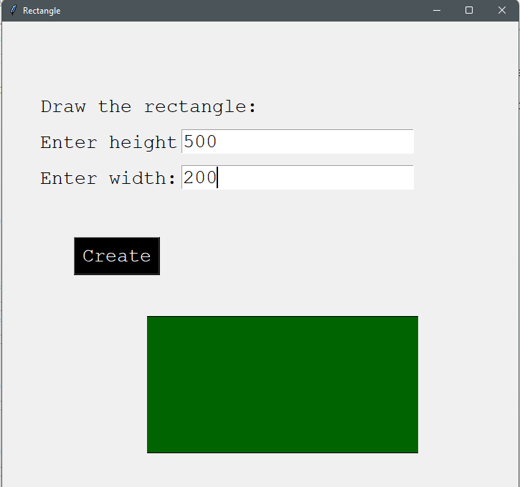

|  |
| --- |
| 16. Create and delete files and folders in Python |

f=open('G:/pythona1.txt','x')

f.write('This file is created by python ')

f.close()

**#FileCreated**

import os

os.remove('G:/pythona1.txt')

**#FileDeleted**

import os

os.mkdir('G:/py1')

**#FolderCreated**

import os

os.rmdir('G:/py1')

**#FolderDeleted**

|  |
| --- |
| 17. Reading, Writing and Analyzing from text and CSV files in Python |

**# Reading, Writing and Analyzing from text.**

f=open('F:/pu.txt','w')

f.write('50 20 63 75')

f.write('\n20 15 80 56')

f.write('\n57 45 18 18')

f.close()

f=open('F:/pu.txt','r')

print(f.read())

import re

s=0

c=0

with open('F:/pu.txt', 'r') as file:

for line in file:

data=line.split()

for i in data:

s=s+int(i)

c=c+1

avg=s/c

print('The average is', avg)

|  |
| --- |
|  |

**#Reading, Writing and Analyzing from CSV**

|  |
| --- |
|  |

import csv

with open('F:/a1py.csv','a') as file:

a=csv.writer(file)

a.writerow(['Samaun','7','1500','F'])

a.writerow(['Farhan','3','500','G'])

a.writerow(['Sarhan','5','1000','H'])

with open('F:/a1py.csv','r') as file:

a=csv.reader(file)

for row in a:

print(*row)

|  |
| --- |
|  |

**#AnalyzingCSVfile**

|  |
| --- |
|  |

import csv

with open('F:/a1py.csv','r') as file:

a=csv.reader(file)

next(a)

b=input('Customer name:')

for row in a:

if b==row[0]:print('C.name:',row[0],'Quanity:',row[1],'Price:',row[2],'P.name:',row[3])

|  |
| --- |
|  |